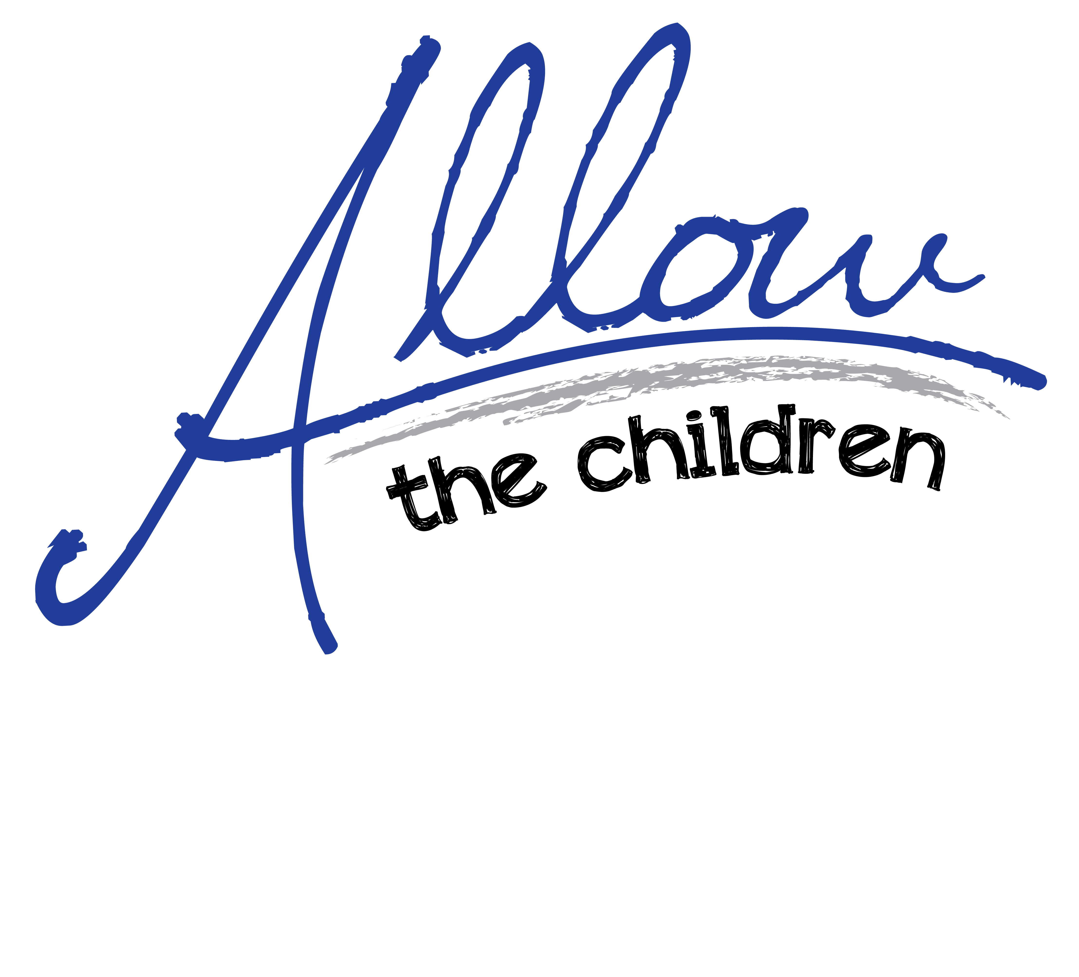

YOUR
Photo
here
Mission Trip to Fill In
Date of Trip
Project: Fill In Name Of Project

Your photo

Your phot

If you can help with the expenses for this mission trip, please send gifts to:
Allow The Children
PO Box 15039
Lynchburg, Virginia 24502-9004

Checks should be made out to Allow The Children
with Insert Your Name on the memo line or on an enclosed note

Contributions can be sent by credit card or check draft through the website at www.allowthechildren.org
with Insert Your Name in the designation box

Your gift will be tax receipted.

P.O. Box 15039 | Lynchburg, VA 24502-9004 | 434-525-8866 | www.allowthechildren.org

